1. **INTRODUCTION**

PUSAT ZAKAT System is a system meant to develop an application to handle the information of the penerima zakat.

**2. OBJECTIVES**

1. The data would be more secured.
2. Easy to add, delete and view the data.
3. Data can be more easily to organized.

**3. CODE**

Private Sub cmdAdd_Click()

If cmdAdd.Caption = "&Add" Then

adozakat.Recordset.AddNew

txtName.SetFocus

DisableButtons

cmdSave.Enabled = True

cmdAdd.Caption = "&Cancel"

Else

adozakat.Recordset.CancelUpdate

EnableButtons

cmdSave.Enabled = False

cmdAdd.Caption = "&Add"

End If

End Sub

Private Sub cmdSave_Click()

If txtName.Text <> "" Then

adozakat.Recordset.Update

EnableButtons

cmdSave.Enabled = False

cmdAdd.Caption = "&Add"

Else

MsgBox "The recordset is empty.", vbInformation, "No Record."

End If

End Sub

Private Sub cmdDelete_Click()

With adozakat.Recordset

.Delete

.MoveNext

If .EOF Then

.MovePrevious

If .BOF Then

MsgBox "The recordset is empty.", vbInformation, "No Record."

DisableButtons

End If

End If

End With

End Sub

Private Sub cmdFirst_Click()

adozakat.Recordset.MoveFirst

End Sub

Private Sub cmdLast_Click()

adozakat.Recordset.MoveLast

End Sub

Private Sub cmdNext_Click()

With adozakat.Recordset

.MoveNext

If .EOF Then

.MoveFirst

End If

End With

End Sub

Private Sub cmdPrevious_Click()

With adozakat.Recordset

.MovePrevious

If .BOF Then

.MoveLast

End If

End With

End Sub

Private Sub DisableButtons()

cmdNext.Enabled = False

cmdPrevious.Enabled = False

cmdFirst.Enabled = False

cmdLast.Enabled = False

cmdDelete.Enabled = False

End Sub

Private Sub EnableButtons()

cmdNext.Enabled = True

cmdPrevious.Enabled = True

cmdFirst.Enabled = True

cmdLast.Enabled = True

cmdDelete.Enabled = True

End Sub

Private Sub cmdExit_Click()

End

End Sub

**4. PRINTSCREENS**

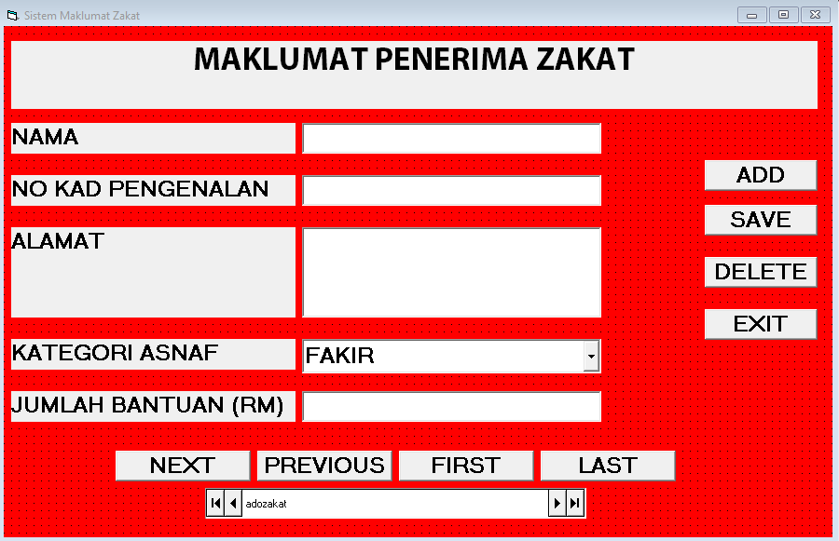

Figure 4.1 – Interface of the system

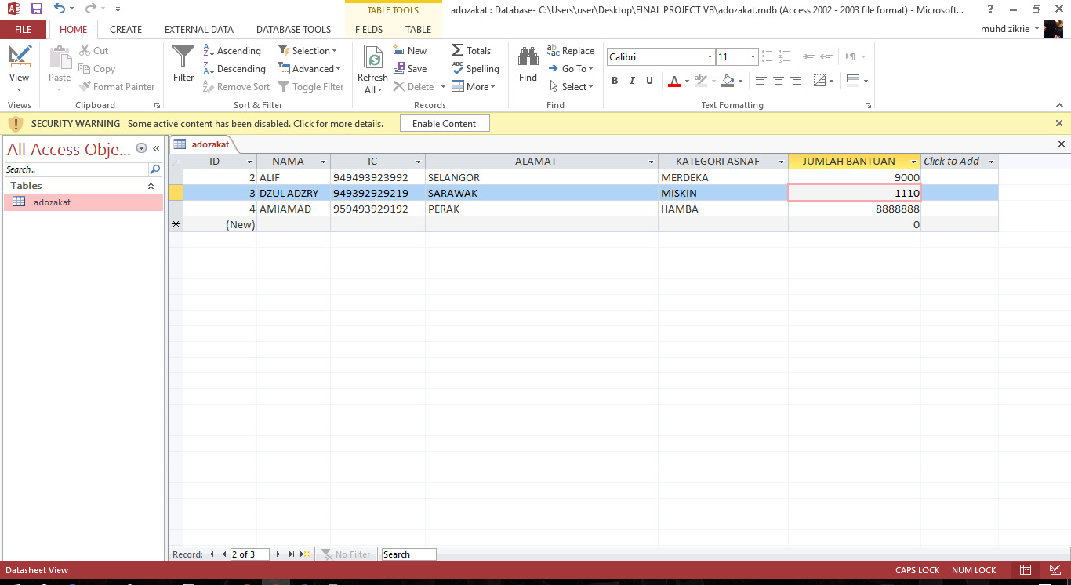

Figure 4.2 – Database table

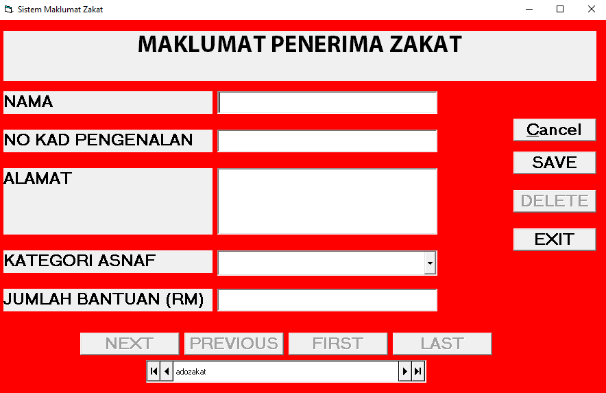

Figure 4.3 – Add data interface of the system

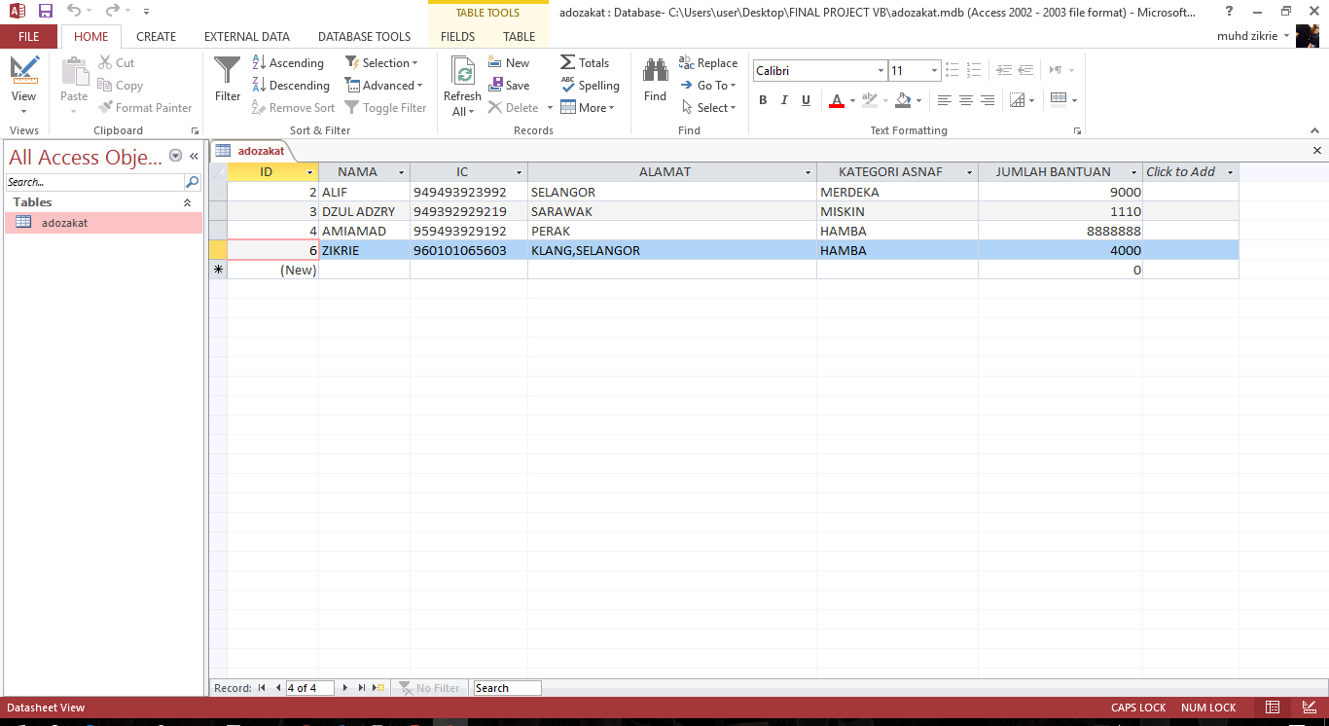

Figure 4.4 – Database table of PUSAT ZAKAT System after data inserted